RECORD OF result analysis
B.A., HEP & B.A., Honors (history)



GOVERNMENT DEGREE COLLEGE for women
srikalahasti -517644
tirupati DISTRICT

Sem wise Results 2024-25
Year | Semester | Paper | Appeared | Passed | Pass %
I | I | I & II
II | III | III &IV
II | III | V | 07 | 07 | 100
II | III | VI | 07 | 07 | 100
II | III | VII | 07 | 07 | 100
II | III | VIII | 07 | 07 | 100
II | IV | IX & X & XI
III | V | VI | 10 | 10 | 100
III | V | VII | 10 | 10 | 100

Sem wise Results 2023-24
Year | Semester | Paper | Appeared | Passed | Pass %
I | I | I | 08 | 08 | 100
I | I | II | 08 | 08 | 100
I | II | III | 08 | 08 | 100
I | II | IV | 08 | 08 | 100
II | III | III | 10 | 10 | 100
II | IV | IV | 10 | 10 | 100
II | IV | V | 10 | 10 | 100
III | V | VI | 20 | 20 | 100
III | V | VII | 20 | 20 | 100


Sem wise Results 2022-23
Year | Semester | Paper | Appeared | Passed | Pass %
I | I | I | 10 | 10 | 100
I | II | II | 10 | 10 | 100
II | III | III | 19 | 14 | 74
II | IV | IV | 18 | 17 | 94
II | IV | V | 18 | 18 | 100
III | V | VI | 17 | 13 | 76
III | V | VII | 17 | 15 | 88
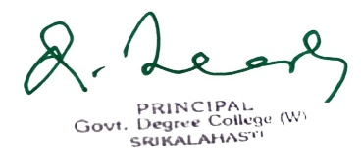
Signature of the HoD Signature of the Principal
Sem wise Results 2021-22
Year | Semester | Paper | Appeared | Passed | Pass %
I | I | I | 23 | 21 | 91
I | II | II | 18 | 10 | 55.5
II | III | III | 18 | 18 | 100
II | IV | IV | 18 | 18 | 100
II | IV | V | 18 | 18 | 100
III | V | VI | 15 | 15 | 100
III | V | VII | 15 | 15 | 100
III | VI | VIII | 15 | 12 | 80
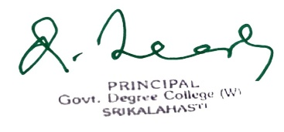
Signature of the HoD Signature of the Principal

Sem wise Results 2020-21
Year | Semester | Paper | Appeared | Passed | Pass %
I | I | I | 20 | 05 | 25
I | II | II | 18 | 18 | 100
II | III | III | 16 | 10 | 62.5
II | IV | IV | 16 | 08 | 50
III | V | V | 12 | 12 | 100
III | V | VI | 12 | 12 | 100
III | VI | VII A | 09 | 09 | 100
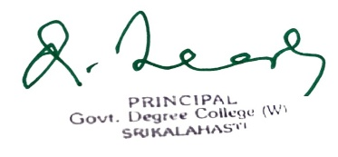
Signature of the HoD Signature of the Principal
Sem wise Results 2019-20
Year | Semester | Paper | Appeared | Passed | Pass %
I | I | I | 21 | 15 | 71.4
I | II | II | 18 | 10 | 56
II | III | III | 11 | 09 | 81.8
II | IV | IV | 11 | 09 | 81.8
III | V | V | 10 | 09 | 90
III | V | VI | 10 | 09 | 90
III | VI | VII | 10 | 09 | 90


Signature of the HoD Signature of the Principal

